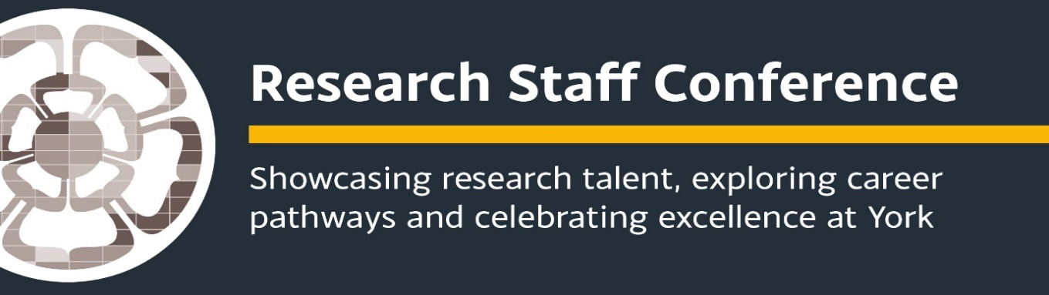
Science Researcher Conference
Treehouse, Berrick Saul Building
26 June 2019

9.00-9.15: Coffee/tea & registration

9.30-9.45: Welcome to the conference – Professor Sue Hartley, York Environmental Sustainability Institute (YESI) Director and Research Champion for Environmental Sustainability and Resilience

09.45-10.10 You said we did: update on the training, support and mentoring available to you and how you can get involved.
Dr Karen Clegg, RETT
& Dr Francina Clayton, Research Staff Liaison Officer for Science

10.10-10.30: Break

10.30-12.00: Celebrating Research: 10 minute presentations from early career researchers

- Sarah Knight, Department of Psychology - Understanding Speech in Background Noise: cognitive listening and the elusive concept of informational masking
- Jamie Gould, Department of Chemistry – Using Porous Materials to Enhance Energy Storage
- Nikita Johnson, Department of Computer Science – Killer Kettles and Connected Vehicles Establishing Confidence in the Safety and Security of Modern Technology
- Rupesh Kumar, Department of Physics – Quantum Communications Using Classical Systems
- Ian Farr, Department of Environment and Geography/Electronic Engineering – Seeing Earthworms in the Dark
- Jonathan Flavell, Department of Psychology – Perceptual Processing and Pleasure
- Liselotte Tinel, Department of Chemistry - A Thin Layer with a Large Impact: How do Naturally Present Microlayers Influence Marine Iodine Emissions?

12.00-12.45: Networking Lunch
Poster display and networking

12.45-14.45: Drawing on her recent research into the Career choices of doctoral candidates in the Sciences, this careers session will be facilitated by Dr Sally Hancock, Department of Education, University of York

Career ideas
This session will draw from employment data and research with early career researchers to explore the wide range of careers open to PhD graduates. By considering the varied contributions PhDs make across society and the economy, the session will inform and support anyone wishing to broaden their post-doctorate career horizons. It will give you the opportunity to reflect on the skills and behaviours you will need to manage your career.

14.45 -15.00: Closing remarks

